Notes on the literature

### Thomas, Adrien. 2021. ‘Framing the Just Transition: How International Trade Unions Engage with UN Climate Negotiations’. *Global Environmental Change* 70: 102347. doi:[10.1016/j.gloenvcha.2021.102347](https://doi.org/10.1016/j.gloenvcha.2021.102347).

* “Our interviewees were high-level trade union officials whose portfolio was ‘the environment’. In many cases this had meant that the traditional trade union issue of health and safety had been broadened to include climate change. Their views did not represent the general view of trade unions, nor probably the majority view of the members within the union they represent. However, the climate change policies of their union depend to a high degree on their ability to convince their colleagues and the broader membership of their views. They can be regarded as the opinion leaders on issues of climate change which is why their positions are worth examining. Trade union policies, like all policies, depend on political conjunctures, including economic, political and social developments.”
* Pretty interesting that international trade unions have something like “climate ministers” and that the climate portfolio is created via adding to existing portfolios
* “For industrial trade unions in Europe and North America, the ecological crisis and the political disputes surrounding crisis management are a strategic challenge. They are often faced with the choice of weighing up long-term ecological goals against short-term labour interests. Should the preservation of existing industrial jobs, including the co-determination and comparatively high wage levels achieved in past struggles, take centre stage? Or should the interests of wage earners in preserving the natural foundations of life be prioritised?”

## Thomas, Adrien, and Nadja Doerflinger. 2020. ‘Trade Union Strategies on Climate Change Mitigation: Between Opposition, Hedging and Support’. *European Journal of Industrial Relations* 26(4): 383–99. doi:[10.1177/0959680120951700](https://doi.org/10.1177/0959680120951700).

* Three strategies
* Opposition
* Polish coalminer union
* Hedging: accept anthropogenic climate change, while trying to minimise regulation
* European steelworkers’ union (IndustriAl)
* <https://news.industriall-europe.eu/Article/58>
* “**An emissions trading system that supports the environment & jobs!**  
  IndustriAll Europe supports the goals of decarbonising industry and greening workplaces. However, organising and ensuring a just transition must not be to the detriment of 'top environmental performers' such as the European steel plants. Fine-tuned measures are needed in order to avoid the counterproductive effects of legislation.
* **Effective trade defence instruments**  
  European industry, and specifically its steel industry, needs to be shielded from products that are produced by companies which do not respect the principles of fair competition and have no regard for environmental or social standards!”
* “The EU ETS is a carbon cap-and-trade scheme that sets binding emission reduction targets for industrial facilities and power plants. Iron and steel production is highly relevant to the debate over reducing emissions because the sector accounts for approximately 5 percent of global CO2 emissions. In the debate over the reform of the EU ETS, IndustriAll Europe and its largest affiliate IG Metall denounced as overly ambitious the climate policy goals of the EU ETS reform and demanded a greater allocation of free emission allowances. While upholding in principle the need for decarbonization, an IndustriAll Europe official responsible for coordinating the steel sector underlined the primary goal of buying time when explaining the organization’s position towards the EU ETS reform:
* We relied heavily on delegates in companies who knew these issues better than us. They told us, listen, the bosses are not wrong about everything. When it comes to reducing CO2 emissions, the European Commission is going a bit too far. We are not able to follow, and if we are forced to follow, it will be the end of steelmaking in Europe. [. . .] High levels of investment are needed to achieve the emission targets, so we have to give ourselves time. The bosses were a little tougher than us on that, with us saying that reduction goals had to be achieved at some point, but we need time to do so. (IndustriAll Europe, Interview, June 2018).”
* Support
* Statement on a Just Energy Transition

* Perhaps what might matter are unions’ internal decision-making procedures.
* “While sector and employment-related concerns can be expected to shape trade unions’ strategies on decarbonization, other factors – for instance, related to unions’ historical trajectories or to their internal decision-making mechanisms – could also play a role. As climate change mitigation is a relatively new topic on which unions are just about to build up expertise, their climate strategies are not necessarily based on an exhaustive analysis of circumstances and evaluation of all the available options, but are likely to be influenced by short-term perceptions and established modes of organizational priority setting.”
* On empirical analysis of mechanisms: text analysis of trade union documents
* “Thus, the flexibility, and in some countries cost advantages, made possible by agency workers was traded off against safeguarding the employment of core workers (who are more likely to be union members), to the detriment of agency workers (who are less likely to be unionized). In sum, trade unions have a record of agreeing to far-reaching concessions when (core) employment is threatened.”
* Method
* Interviews (28) and qualitative text analysis, 2017 to 2020
* “The interviews were carried out with international trade union officials (ITUC), European-level union officials (European Trade Union Confederation (ETUC), European Federation of Public Service Unions (EPSU), IndustriAll Europe), national-level union officials (German IG Metall, Polish NSZZ Solidarność, Luxembourg’s Onofhängege Gewerkschaftsbond Lëtzebuerg and Lëtzebuerger Chrëschtleche Gewerkschaftsbond), company-level union representatives (ArcelorMittal’s European Works Council), employer representatives (World Steel Association, ArcelorMittal) and representatives of the European institutions and member states (DG Environment, EU Council working party Environment). In parallel, we analysed a large range of related secondary data – particularly archived ITUC documents, newspaper articles, trade union publications and industry reports (in English, French, German and Dutch) – with two purposes in mind: first, to validate the information provided to us in the interviews; second, to identify interesting cases/strategies at European and national level (which were in turn also a topic in the interviews).”
* “Findings”
* “This may also involve choosing between the interests of different member groups. For instance, when adopting its position on the EU ETS, IG Metall needed to weigh up the interests of the steelmaking segments of its membership against those of its members working in renewables. The greater organizational weight of steelworkers within the union helped tip the scales in favour of the steel industry.”

## Kalt, Tobias. 2022. ‘Agents of Transition or Defenders of the Status Quo? Trade Union Strategies in Green Transitions’. *Journal of Industrial Relations* 64(4): 499–521. doi:[10.1177/00221856211051794](https://doi.org/10.1177/00221856211051794).

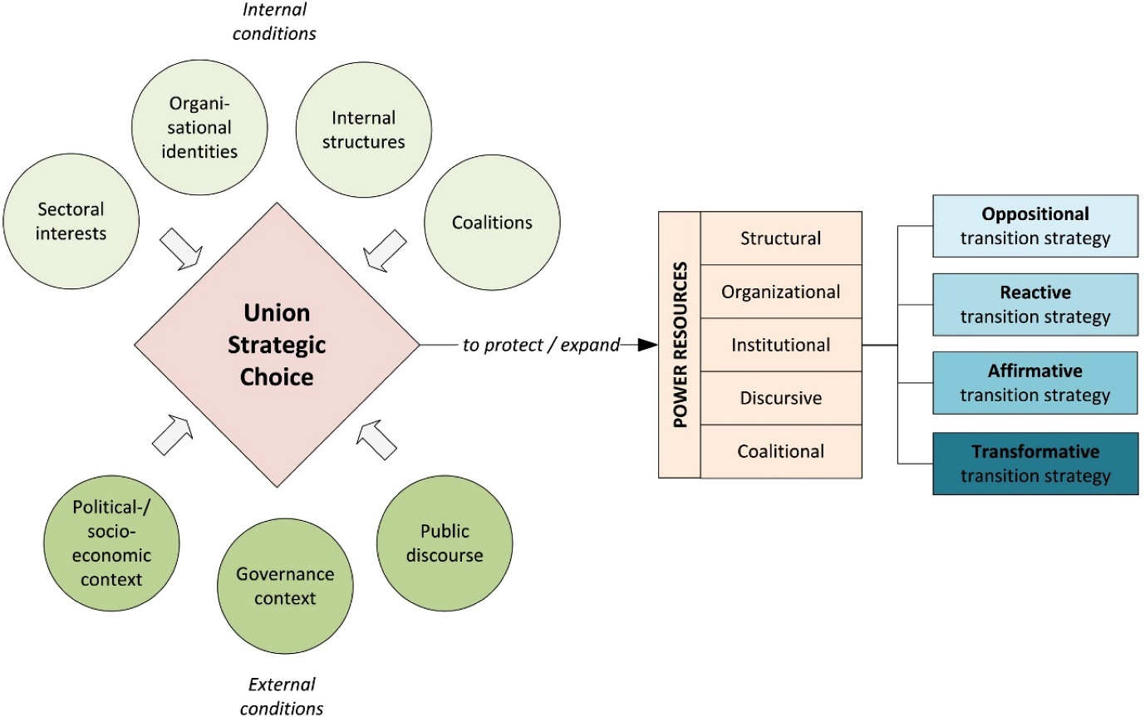

* “Firstly, *sectoral interests*, referring to the economic sectors in which unions organise, have been identified in the literature as a particularly salient factor ([Clarke and Lipsig-Mummé, 2020](https://journals.sagepub.com/doi/10.1177/00221856211051794?icid=int.sj-full-text.similar-articles.1#bibr6-00221856211051794); [Snell and Fairbrother, 2011](https://journals.sagepub.com/doi/10.1177/00221856211051794?icid=int.sj-full-text.similar-articles.1#bibr46-00221856211051794); [Thomas and Doerflinger, 2020](https://journals.sagepub.com/doi/10.1177/00221856211051794?icid=int.sj-full-text.similar-articles.1#bibr54-00221856211051794)). As labour’s fate in the treadmill of production is tied to the expansion of economic activity, unions’ structural and associational power depends on the economic well-being of the sectors in which unions organise ([Schnaiberg, 1980](https://journals.sagepub.com/doi/10.1177/00221856211051794?icid=int.sj-full-text.similar-articles.1" \l "bibr42-00221856211051794)). [Clarke and Lipsig-Mummé (2020](https://journals.sagepub.com/doi/10.1177/00221856211051794?icid=int.sj-full-text.similar-articles.1#bibr6-00221856211051794): 363) state that ‘union strategies depend very much on the sector, whether it is associated with greater or lesser carbon emissions and whether employment gains or losses are envisaged’. As high-carbon sectors decline and low-carbon sectors expand through green transitions, unions tied to high-carbon sectors are likely less supportive of green transitions than those in low-carbon sectors.”
* “Secondly, union strategies also depend on *governance contexts*, i.e. the industrial relations system, the role of the state and policy discussions on decarbonisation and just transition. The state may take on an active role that includes reaching out to unions in a state-led green transition or it may play a more limited role, shutting out unions from policy-making and enabling market-led green transitions. [Snell (2019](https://journals.sagepub.com/doi/10.1177/00221856211051794?icid=int.sj-full-text.similar-articles.1#bibr44-00221856211051794): 214) argues that a just transition ‘depends upon an interventionist state committed to social partnership and union involvement in the transition process’. We can expect more union support for green transitions if just transition policy initiatives are on the table and the industrial relations system allows unions to exercise institutional power in the policy process.”
* Comparative case study
* Germany
* “ Even though Germany is often regarded as an energy transition pioneer, the coal sector has remained mostly unaffected by energy transition policies for a long time. This began to change in 2015 when the government attempted to place climate levies on old coal power plants. Due to pressures from the coal regime including unions, the policy initiative was eventually defeated. In subsequent years, a growing climate justice movement that organised mass actions of civil disobedience in the coal regions put the coal phase out on the political agenda ([Kalt, 2021](https://journals.sagepub.com/doi/10.1177/00221856211051794?icid=int.sj-full-text.similar-articles.1#bibr30-00221856211051794)). In 2018, the federal government launched the Commission for Growth, Structural Change and Employment (popularly known as Coal Commission), a multi-stakeholder social dialogue forum that included, among others, top-level union representatives. The commission recommended a slow phase out of coal up until 2038 accompanied by social plans for affected workers and plans for regional infrastructural and industrial development. Based on the commission’s recommendations, in 2020 the federal government passed a phase out law and a transition law equipped with 40-billion-euro state funding. Subsequently, the phase out law has come under criticism for unnecessarily delaying the coal transition, for not being in line with Paris climate targets and for ignoring key recommendations of the Coal Commission ([Heimann and Popp, 2020](https://journals.sagepub.com/doi/10.1177/00221856211051794?icid=int.sj-full-text.similar-articles.1#bibr20-00221856211051794)).”
* “Both in South Africa and Germany, unions are important social and political forces. In Germany, union membership has fallen steeply since the 1990s and less so in recent years leading to a union density rate of currently 17% (ILO, n.d.). After a few mergers, the largest unions in Germany are now the metalworkers’ union IG Metall, the service sector union Verdi and the mining, chemicals and energy union IG BCE that are all part of the German Trade Union Confederation (DGB). **Central to Germany’s industrial relations system is a conflict partnership model in which unions act as intermediary organisations to reconcile capital and labour interests through policy coordination, collective bargaining and co-determination in ways that are often accompanied by conflicts (**[**Müller-Jentsch, 1999**](https://journals.sagepub.com/doi/10.1177/00221856211051794?icid=int.sj-full-text.similar-articles.1#bibr34-00221856211051794)**).** Yet, due to neoliberal globalisation and the weakening of union power, this industrial relations model has been unravelling.”
* “Union transition strategies in Germany and South Africa range from oppositional to transformative. Initially, IG BCE pursued oppositional strategies. The union opposed climate levies on coal power and was sceptical of a climate-driven phase out. Over time, IG BCE shifted from an oppositional to a reactive strategy. It accepted the need for an early phase out yet attempted to delay the transition and cushion its effects on its members. This was done by arguing for the need for coal as ‘a crucial bridging technology for the energy transition’ (IG BCE, interview). DGB, Verdi and IG Metall tend toward more affirmative strategies that support the ecological modernisation of the economy. While segments within both Verdi and IG Metall would like to see their unions pursuing more transformative transition strategies, these positions remain marginalised.”
* 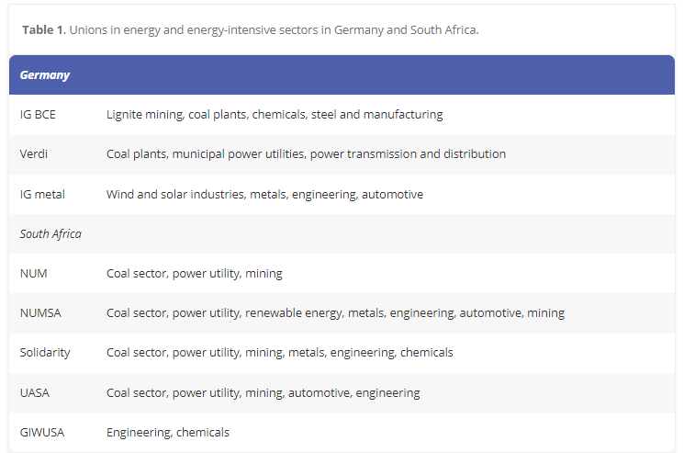

## Hydrogen Corporatism and Working Time Reduction. Union Strategies in the Transformation of German Primary Steel Manufacturing

* “This working paper focuses on the disputes surrounding the decarbonisation of the steel industry in Germany and the approach taken by IG Metall. It provides an interesting example of how a trade union is attempting to position itself as a "driver of transformation" (Lehndorff 2023) and shows the contradictory relationship between dialogue- and conflict-oriented approaches. In the 2023 collective bargaining round, the union demanded a reduction in working hours to 32 hours a week or a 4-day week. **Such a reduction in working hours, chief negotiator Knut Giesler explained, would not only be a "real relief" for employees but an advance in quality of life and health. The four-day week would also make the steel industry more attractive for young people, who are urgently needed in the conversion of coal-based heavy industry to low-emission production processes**. At the same time, a reduction in working hours could also prevent job losses in connection with this restructuring. (Handelsblatt, April 5, 2023) Although the negotiations on the working time issue ended with a moderate result (see Chapter 5.2), it is worth taking a closer look at this attempt by IG Metall to bring together "social" and "ecological" progress in the transformation. As will become clearer later on in this working paper, **the given constellation in the steel industry is not primarily structured as a jobs versus environment dilemma; it is not the industry as a whole and its products that are questioned for climate policy considerations, but certain aspects of the production process**. (Blöcker 2022) Compared to other industries, this makes it easier for a trade union to affirm change and focus on influencing it in a spirit of social partnership. IG Metall has been doing this for several years with the slogan "Our heart of steel has a green future".”
* “The German steel industry produced 36.8 million tons of steel in 2022; this puts the country in seventh place in the global ranking of steel production volume. Approximately 30 percent of the steel produced in Germany is accounted for by the so-called secondary route, i.e. the processing of steel scrap in electric arc furnaces (World Steel Association 2023). This paper focusses on the 70 percent primary steel production via so-called iron ore reduction in the blast furnace. This process for producing pig iron as a steel precursor accounts for the vast majority of the steel industry's CO₂ emissions. In 2022, German steel industry's production of 36.8 million t steel processed 18.2 million t of hard coal. The most important countries of origin for coal imports to Germany were Russia, Colombia, the USA, and Australia (VdKi 2023: 11f.). There are still five locations in Germany for primary steel production in the blast furnace route. These are Duisburg with an annual production capacity of 11.5 million t, Salzgitter (5.2 million t.), Bremen (3.8 million t.), Völklingen (3.2 million t.), Dillingen (2.7 million t.) and Eisenhüttenstadt (2.4 million t.) (Eurofer n.d.) In the course of decarbonization, coal is to be replaced by hydrogen as a reducing agent.”
* “The co-determination rules in the coal and steel industry (Montanmitbestimmung) were developed in the British zone after World War II and adopted for the Federal Republic in 1951. **It includes parity codetermination on the supervisory board of a company and the appointment of labor directors on the management board, who are usually proposed by the trade unions. In addition, there are the codetermination mechanisms under the Works Constitution Act**, i.e., the establishment of a works council that is obliged to cooperate "in a spirit of trust" with the management and that has limited rights of co-decision, information, and control. In addition, union shop stewards (Vertrauensleute) can be of importance as representatives of the union.”
* “At the same time, trade unions and business associations have worked to influence the reform of the European Emissions Trading Scheme ETS. The trade union federation IndustriAll, whose largest member organization is IG Metall, is of central importance for trade union influence on European policy decisions. The Eurofer association represents the steel employers. In the first two trading periods of the ETS, the German steel industry received CO₂ certificates on average from 2008 to 2020 to such an extent that no climate protection incentives were created, but instead, extra profits were generated. (Witt 2022: 13) **IndustriAll and Eurofer jointly opposed efforts to reform this ineffective system using both lobbying in the background and public campaigns. The dismantling of free certificate allocation was unanimously seen as a competitive disadvantage**; by the trade unions, the changes were interpreted not as an incentive to develop more climate-friendly production processes, but as pressure to reduce European production capacity. Against the vote of several affiliates (including the French CGT and the Italian FIOM), IndustriAll took part in a demonstration initiated by Eurofer in Brussels in February 2016, criticizing Chinese dumping and European climate protection as a threat to the steel industry. IndustriAll again mobilized for a demonstration in November of the same year but rejected Eurofer's offer to participate so as not to exacerbate its internal conflict. However, this did not prevent several steel companies from paying for travel expenses and meals for demonstrating employees. (Thomas 2021) IG Metall was still contesting these demonstrations under the slogan "Our heart of steel must continue to beat". With the adoption of the EU's Green Deal and the reform of ETS in 2019, it was adapted as "Our heart of steel has a green future" to reflect the increased political pressure for climate protection measures**. In the current ETS trading period, free allocations will be phased down from 2026 on; the total quantity of certificates auctioned will be reduced. As a safeguard against "carbon leakage" (relocations due to CO₂ costs), a special tariff will be introduced (see below: CBAM).”**

## The Hassel paper

## Other notes

* Data on coal mines at the NUTS2 level are available
* A map of europe with different colored areas

  Description automatically generated<https://www.researchgate.net/profile/Wouter-Nijs/publication/326722908_EU_coal_regions_opportunities_and_challenges_ahead/links/5b6972aba6fdcc87df6d6b4e/EU-coal-regions-opportunities-and-challenges-ahead.pdf>
* A map of europe with orange circles and numbers

  Description automatically generated
* A map of europe with orange dots

  Description automatically generated
* A map of europe with red and white squares

  Description automatically generated

* **Institutional spin on Gaikwad et al.** 
  + **What do cross-pressured individuals want in terms of institutions in Europe?**
  + **Two innovations:**
    - **Theoretical side: Apply and extend their framework to institutions**
    - **Empirical side: Apply it to Europe**